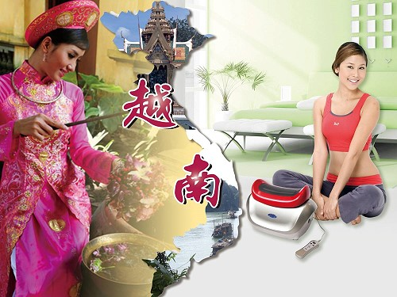
Shake the world Chi Machine！
618-successful way！
Hsin Ten Vietnam, Let’s effort！

興田越南分公司產品上市發表會

Hsin Ten Vietnam branch product listing presentation

Dear Hsin Ten people around the world , hi…everybody :
With extremely excited mood, in this we tell you a good news , that is Hsin Ten Vietnam branch has been officially launched.
Shake the world Chi Machine！
618-successful way！ Product listing presentation
As a distinguished of your , certainly would not miss this great opportunity to expand internantional bussiness. In addition to warmly invite you to visit participation , and we hope you will bring this message to inform your Vietnamese friends or Vietnamese cousin , tell them to come together to particcipate in this successes o this rare event.
Date ：October 2 ,2010 (Saturday)
Time ：14:00–16:00(13:30 approach)
Location :7th floor recreation room Windsor Hotel, Ho Chi Minh City
Address：18 An Duong Vuong Street,District 5, Ho Chi Minh City

Chairman Gordon Pan
Asia COO Simon Yan
Vietnamese company Deputy GM David Wen Respect invitation
August 20th , 2010

THE Hsin Ten international group興田國際集團

