
海外國際推薦專用版

‧The ticket/coupon you can pass to your Vietnamese friends to print, have the same effect.

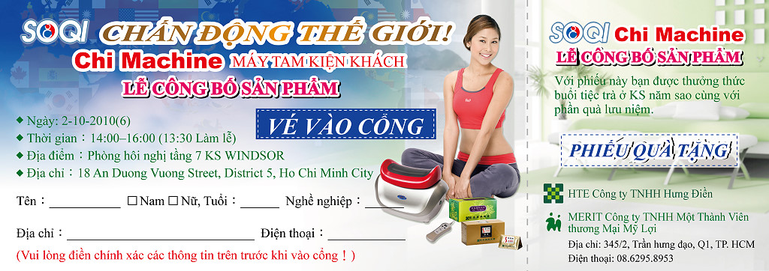
海外國際推薦專用版

‧The ticket/coupon you can pass to your Vietnamese friends to print, have the same effect.
.

